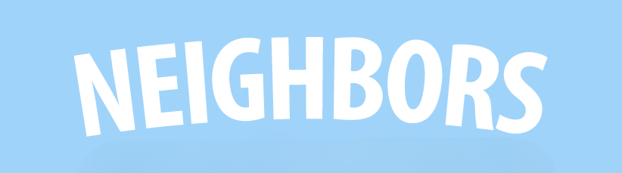

MONDAY, SEPT. 22, 2025 Seek Excellence with Humility Janet Ayers Academic Center: 4th Floor Conference Room
Time | Event
9:30 | SYMPOSIUM KICKOFF! - Join us for opening remarks to kick off the 24th Annual Humanities Symposium
10:00 | FEATURED SPEAKER: KHALIL EKULONA - "All Are Invited: How Honor, Authenticity, & Grace Guides us through Divisive Times"
11:00 | DR. JOEL OVERALL - "The Monteverde Lecture: Where Everyone Knows Your Name: How to be a Regular"
12:00 | DR. CHARMION GUSTKE, DR. DOUGLAS MURRAY, DR. NATHAN GRIFFITH - "The Closer We Are Together the Further We Are from Care (or so it seems)"
1:00 | WELCOME RECEPTION
2:00 | CHRIS THIESSEN - "Listening for the Love of Neighbor: How Popular Music Participates in the Pursuit of Just Relationships"
6:00 | "ROOTS SO DEEP" PT. I - Documentary Screening (*1890 Theater, Jack C. Massey Center)

TUESDAY, SEPT. 23, 2025 Offer Gratitude with Joy Janet Ayers Academic Center: 4th Floor Conference Room
Time | Event
11:00 | DR. ANN COBLE - "Who Is My Neighbor? Reflections on the Parable of the Good Samaritan"
12:30 | DR. KACIE HITTEL & PROFESSOR DAN BRAWNER - "Seeing Our Non-Human Neighbors: A Drawing and Writing Workshop"
2:00 | JEFF MOLES, JASMINE LEDSINGER, AMANDA CLELLAND - "Nashville Neighbors: Room in the Inn, The Store, and Thistle Farms"
3:30 | DR. KEVIN TROWBRIDGE, DR. ANNA GRACE USERY, DR. CHRISTIE KLEINMANN - "Won't You Be My (AI) Neighbor? The Reconceptualization of Relationships in the Age of Artificial Intelligence"
6:00 | "ROOTS SO DEEP" PT. II - Documentary Screening (*1890 Theater, Jack C. Massey Center)

WEDNESDAY, SEPT. 24, 2025 Unleash Hospitality with Love Janet Ayers Academic Center: 4th Floor Conference Room
Time | Event
9:00 | DR. MICHELLE E. SHAW - "Rhetoric Next Door: How We Talk About the Neighbor"
10:00 | FEATURED SPEAKER: TOM JUNOD - "Be a Man: Mister Rodgers, My Father, and Me"
11:00 | DR. KACIE HITTEL - "How to Be a Derry Girl"
12:00 | DR. BARRY BALLINGER - "Don't You Be My Neighbor: Criminalizing Neighborliness Through Zoning"
1:00 | DR. JUDY SKEEN - "Neighbors with Paws, Claws, and Hooves"
2:00 | DR. NOEL BOYLE - "Doulia Neighborhood: Kittay on Dependency and Community"
3:00 | TOM JUNOD - "Student Writing Workshop" (*RSVP Required)
6:00 | "ROOTS SO DEEP" PT. III - Documentary Screening (*1890 Theater, Jack C. Massey Center)

THURSDAY, SEPT. 25, 2025 Live the Dream Together with Hope Janet Ayers Academic Center: 4th Floor Conference Room
Time | Event
9:30 | JOYCE SEARCY - "Life, Liberty, and the Pursuit of Happiness: Chasing the American Dream with Your Neighbor"
11:00 | FEATURED SPEAKER: DR. ERIC CALDERWOOD - "Bridges and Borders in the Legacy of Al-Andalus"
12:30 | DR. CHRISTINA ANANIAS - "Joining Our Neighbors in Worship: Strengthening Intergenerational Ties Through Music"
2:00 | DR. BLAKE W. REMINGTON - "Watching, Looking, Viewing: Neighbors Then and Now" (*Brief talk in Ayers, then walk to "Some Were Neighbors" Holocaust Exhibition at Bunch Library)
4:30 | Reception & Gallery Talk - "Neighbors: Artist in Residence at Arcade Arts" (Leu Art Gallery)
6:00 | "ROOTS SO DEEP" PT. IV - Documentary Screening and Panel Discussion with Featured Farmers (*1890 Theater, Jack C. Massey Center)

FRIDAY, SEPT. 26, 2025 S.O.U.L. Janet Ayers Academic Center: 4th Floor Conference Room
Time | Event
9:00 | DR. BETH RITTER-CONN - "Divine Disruption: The Gift and Challenge of Radical Hospitality"
10:00 | PHILOLOGOI PHILOSOPHY CLUB - "Join us for a moderated discussion with Philosophy Faculty and Students"
11:00 | DR. DAVID DARK - "Art, Empire, & the End of the World: Loving My Neighbor in the Everyday Apocalypse"
11:45 | Teaching Center Luncheon - Service Learning Panel Discussion (*RSVP Required)
1:00 | DR. RAY CHAO - "Neighbors, Fear, and the Law: The Trayvon Martin Case and Its Legacy"
2:00 | SANDRA HUTCHINS - "Creative Writing Awards: Featured Readings: Student Writers"
4:00 | FEATURED SPEAKER: C.J. SENTELL - "Neighbor as Verb: Practicing the Politics of Hospitality"
5:00 | Closing Reception - Food catered by The Nashville Food Project

Special Thanks to The Louie M. & Betty M. Phillips Foundation



